

DEPARTMENT OF MATHEMATICS


POSTER PRESENTATION

Theme: Mathematics for a Better Tomorrow
Date: 16 December 2025
1 | Date | 16 DECEMBER 2025
2 | Conducted through DRC/JKC/ELF/Dept.etc | Department of Mathematics
3 | Nature of Activity | Poster Presentation
4 | Title of Activity | Poster Presentation - “Mathematics for a Better Tomorrow”
5 | Name of the Department / Committee | Department of Mathematics
6 | Details of Resource person | Dr.M.Surekha, Lecturer in Physics, Dr.Ch.Praveen, Lecturer in Chemistry and Faculty of Department of Mathematics
7 | No.of students participated | 28
8 | Activity outcomes: | - Students understood the practical importance of Mathematics.  - Improved creativity and analytical thinking  - Enhanced communication and presentation skills.  - Developed confidence in expressing ideas  - Recognized Mathematics as a tool for future development.
9 | Name of the lecturer who planned and conducted the activity | Department of Mathematics
10 | Signature of the In-charge | 
11 | Signature of the Principal | 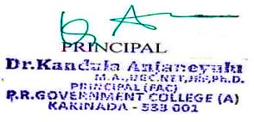

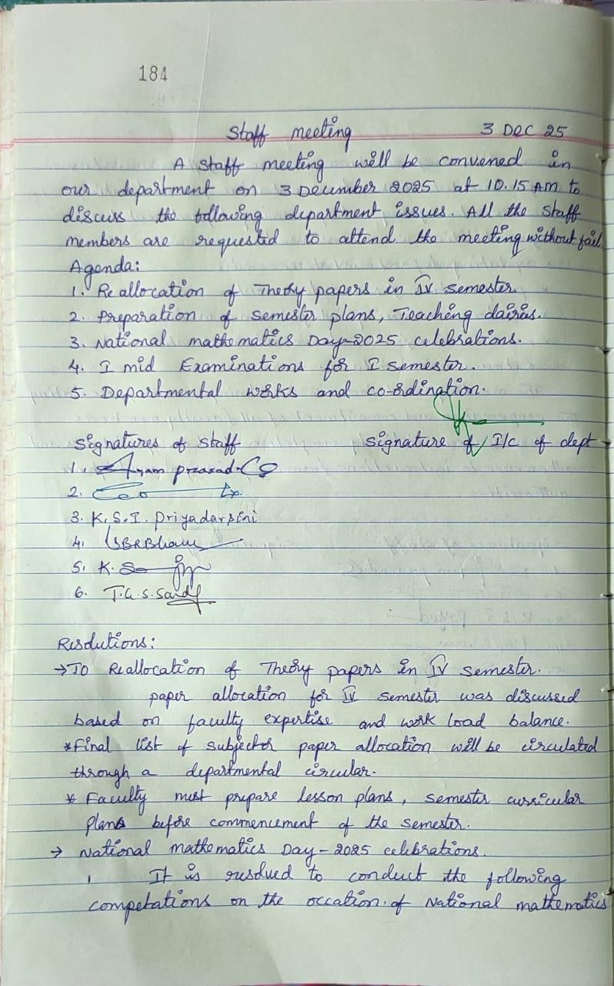
Department Minutes and Resolutions

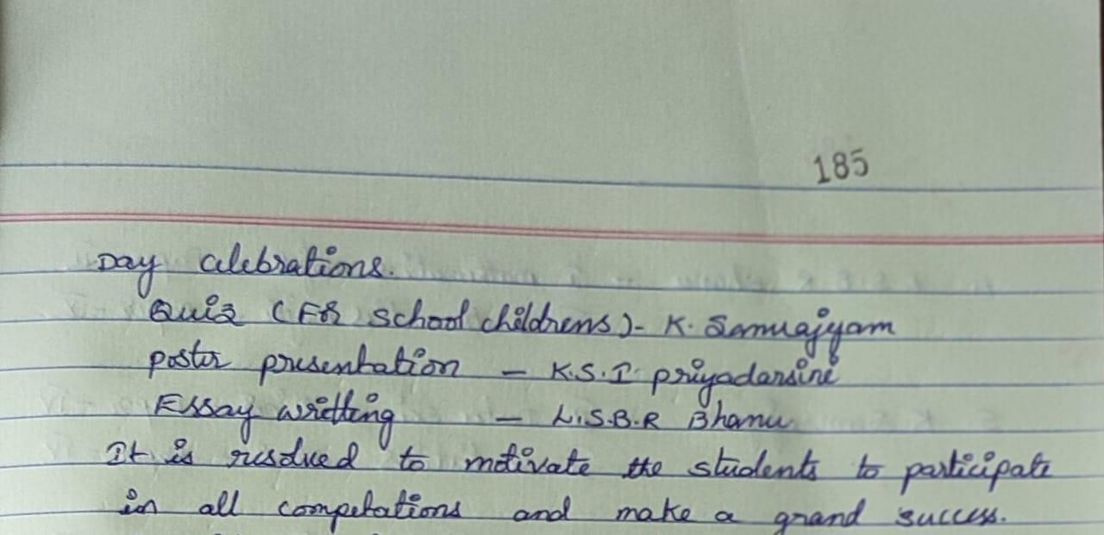
Principal Permission Letter
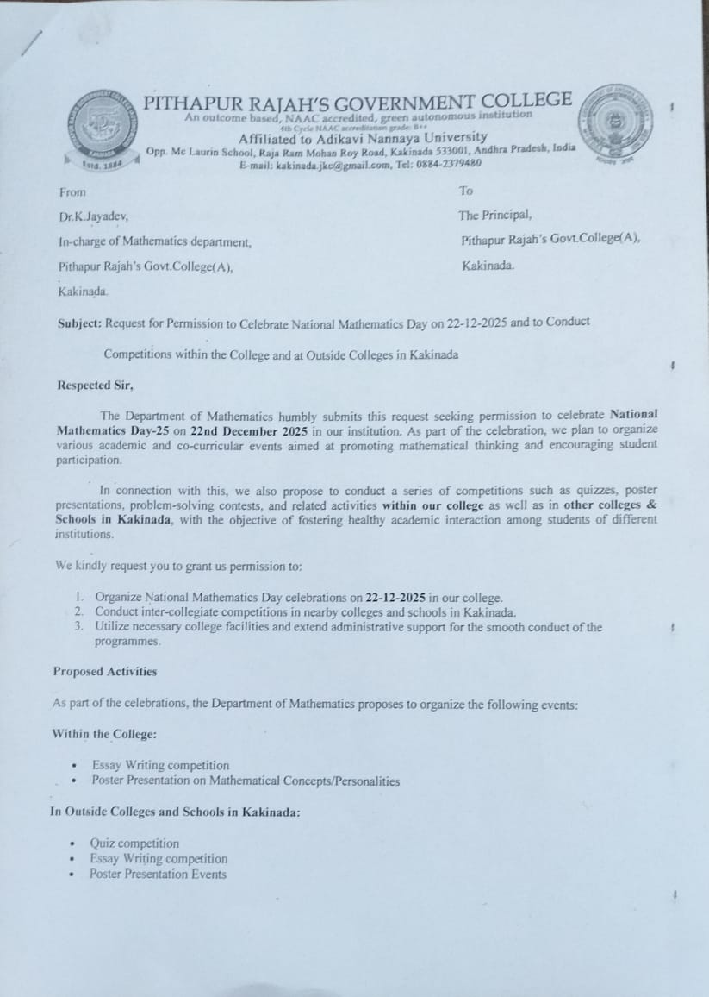

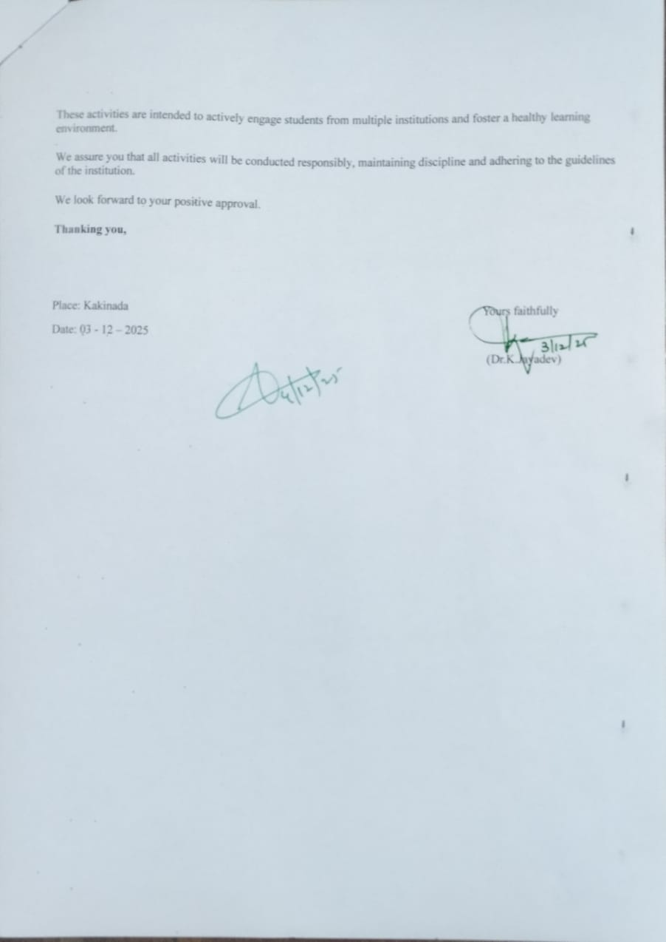

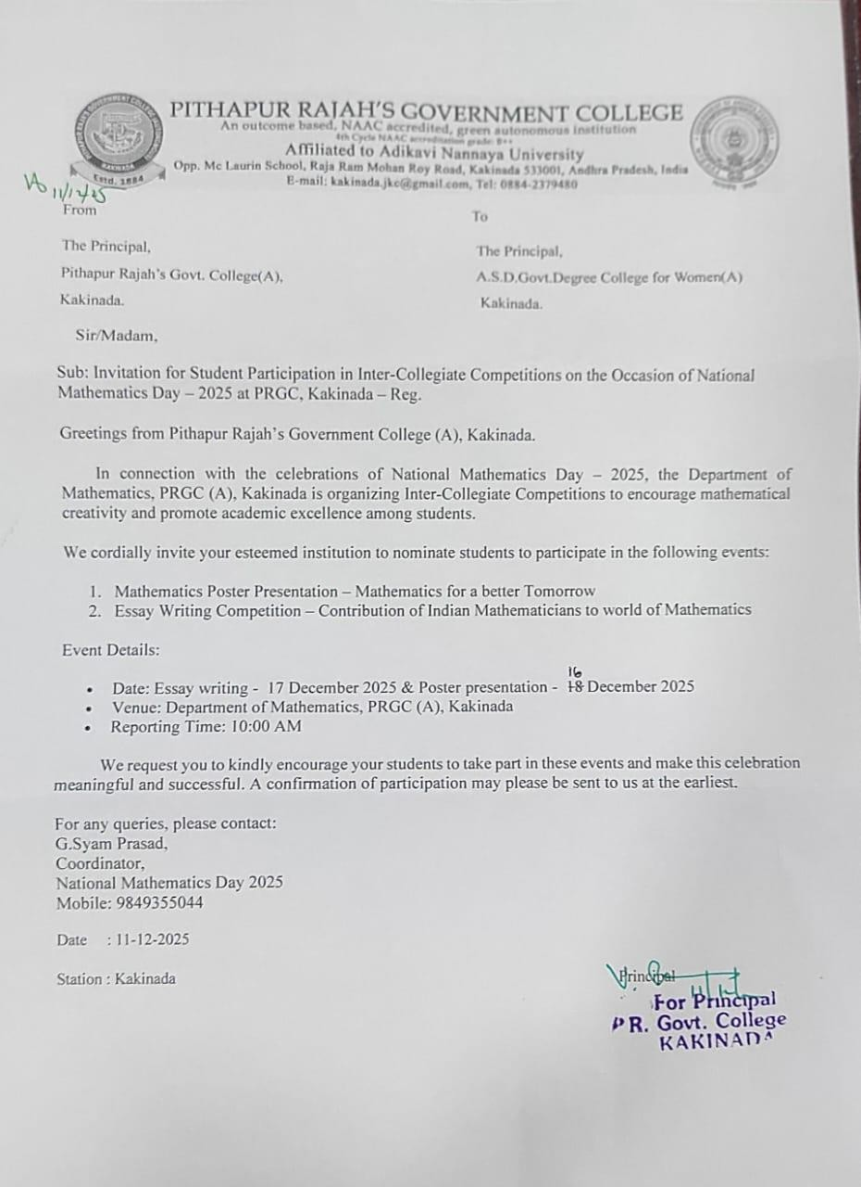
Invitation for students of A.S.D.Govt.Degree College for Women(A)

Invitation for students of Ideal College of Science & Arts(A)
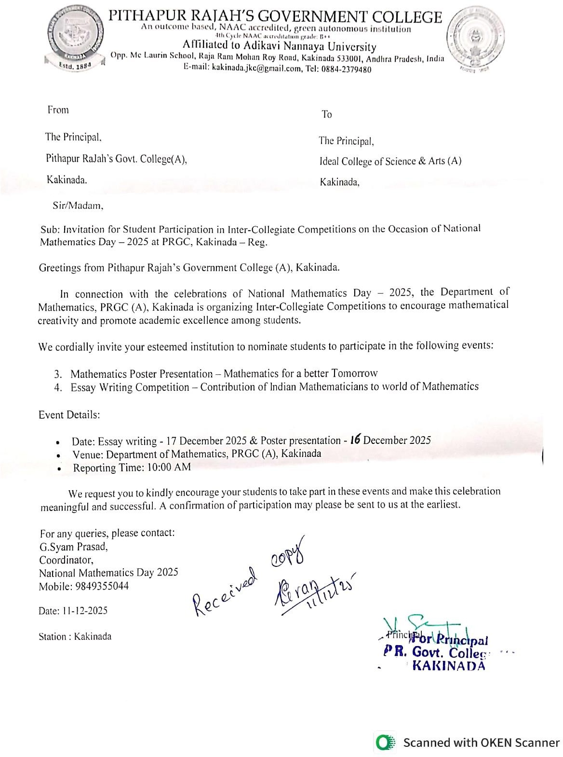
STUDENTS NOTICE


DEPARTMENT OF MATHEMATICS
NOTICE
The Department of Mathematics is delighted to announce that, on the occasion of National Mathematics Day, a series of academic and creative events will be conducted to honor the legacy of mathematical brilliance and inspire students to appreciate the importance of mathematics in everyday life.
To mark this special day, the following competitions will be organized:

1. Mathematics Poster Presentation
Theme: Mathematics for a Better Tomorrow
Students are invited to design visually appealing and conceptually strong posters showcasing the role of mathematics in shaping a progressive, scientific, and technologically advanced future. Posters may highlight concepts, innovations, real-life applications, or futuristic ideas influenced by mathematical thinking.

2. Essay Writing Competition
Topic: Contribution of Indian Mathematicians to the World of Mathematics
Participants are encouraged to write thoughtful and well-structured essays exploring the invaluable contributions of Indian mathematicians—from ancient to modern times—who have enriched the global mathematical landscape. Essays may include historical insights, noteworthy discoveries, and the lasting influence of Indian mathematical traditions.

Event Details:
- Date: Poster Presentation: 16-12-2025 & Essay Writing Competition: 17-12-2025
- Time: 11.00 AM
- Venue: At Mathematics Department – Ramanujan Lecture Hall
- Participant Eligibility: Open to all interested students
- Registration Process: Submit your names to the Mathematics Department or the respective class coordinators on or before 15-12-2025
- Judging Criteria: Creativity, originality, clarity of presentation, and relevance to the theme
- Awards: Winners will receive certificates and attractive prizes.

Note:

Students are encouraged to participate whole-heartedly and make this celebration meaningful. Let us honor the spirit of National Mathematics Day by recognizing the importance of mathematics in shaping knowledge, innovation, and the future of our nation.
— Department of Mathematics
Signature of the I/C of the Dept.

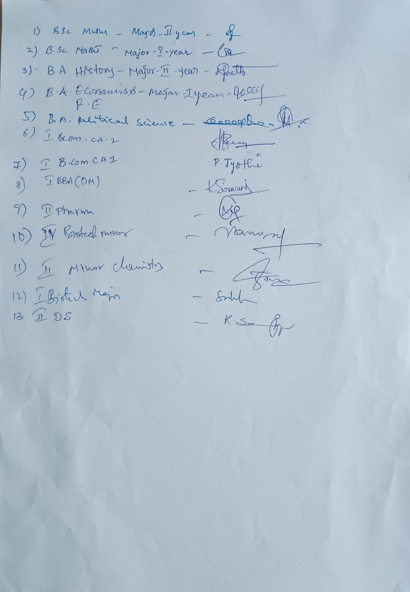

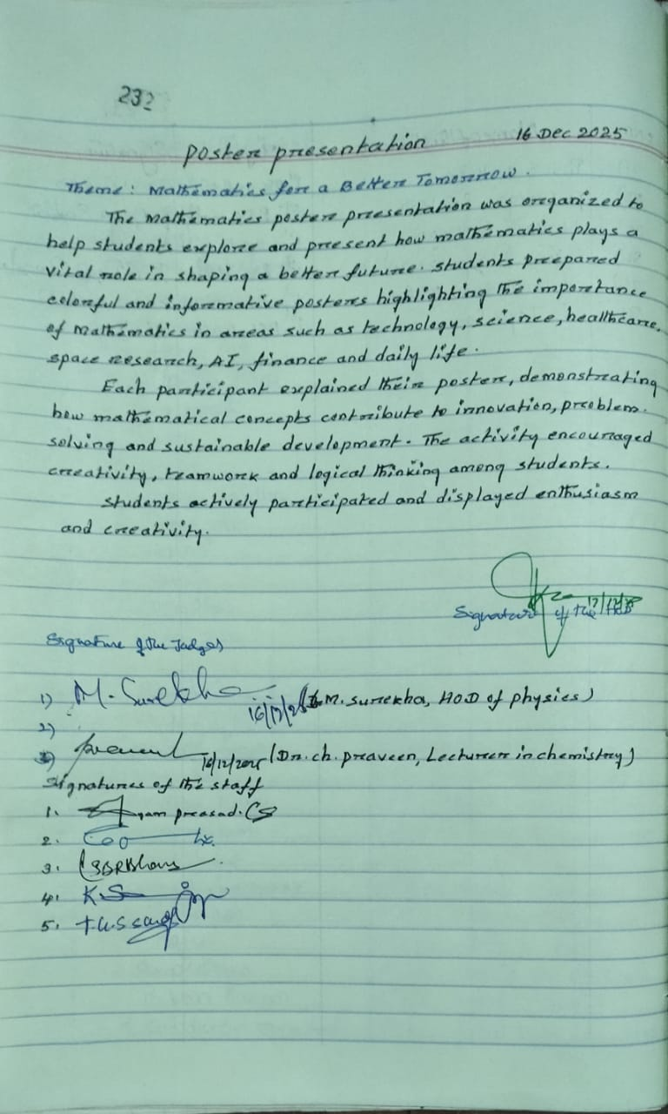

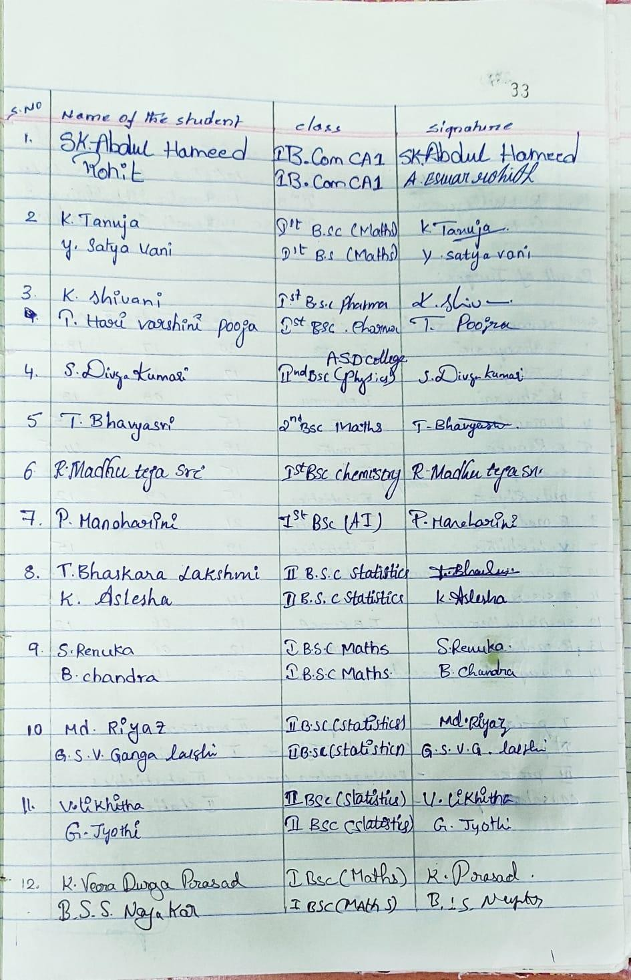
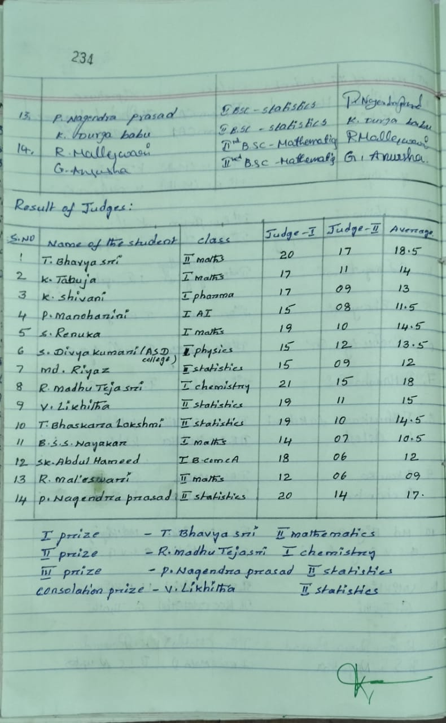

POSTER PRESENTATION

Theme: Mathematics for a Better Tomorrow
Theme Explanation
The theme “Mathematics for a Better Tomorrow” focuses on how Mathematics plays a crucial role in shaping the future. It highlights the importance of mathematical thinking in technology, innovation, environmental protection, healthcare, artificial intelligence, space research, and everyday problem-solving.

Objectives of the Activity
- To help students understand the real-life applications of Mathematics
- To encourage creativity and critical thinking
- To show how Mathematics contributes to a better and sustainable future
- To develop presentation and communication skills
- To promote interest and confidence in Mathematics

Rules and Guidelines
- Each poster must be based on the given theme.
- Posters should be handmade.
- Mathematical concepts should be clearly explained.
- Students must be prepared to explain their posters.
- Use of pictures, diagrams, and formulas was encouraged.
- Time limit for explanation: 2–3 minutes per participant.

Theme
“Mathematics for a Better Tomorrow”

Description of the Activity
The Mathematics Poster Presentation was organized to help students explore and present how Mathematics plays a vital role in shaping a better future. Students prepared colorful and informative posters highlighting the importance of Mathematics in areas such as technology, science, environment, healthcare, space research, artificial intelligence, finance, and daily life.
Each participant explained their poster, demonstrating how mathematical concepts contribute to innovation, problem-solving, and sustainable development. The activity encouraged creativity, teamwork, and logical thinking among students.

Procedure
- Students were informed about the theme in advance.
- They prepared posters based on real-life applications of Mathematics.
- Posters were displayed in the designated area.
- Each student explained their poster to teachers and peers.
- Teachers evaluated the posters based on creativity, relevance, clarity, and presentation skills.

Learning Outcomes
- Students understood the practical importance of Mathematics
- Improved creativity and analytical thinking
- Enhanced communication and presentation skills
- Developed confidence in expressing ideas
- Recognized Mathematics as a tool for future development

Judging / Assessment Rubric
Criteria | Marks
Relevance to Theme | 5
Creativity & Innovation | 5
Clarity of Content | 5
Presentation Skills | 5
Neatness & Visual Appeal | 5
Total | 25

Outcome of the Activity
The activity was a great success. Students actively participated and displayed enthusiasm and creativity. The posters reflected innovative ideas and a clear understanding of how Mathematics contributes to building a better tomorrow.

Conclusion
The Mathematics Poster Presentation proved to be an effective and engaging activity. It helped students connect mathematical concepts with real-world applications and inspired them to appreciate the importance of Mathematics in shaping the future.
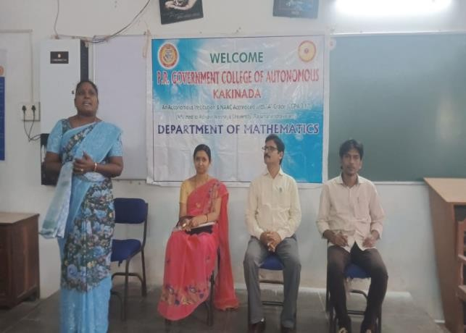
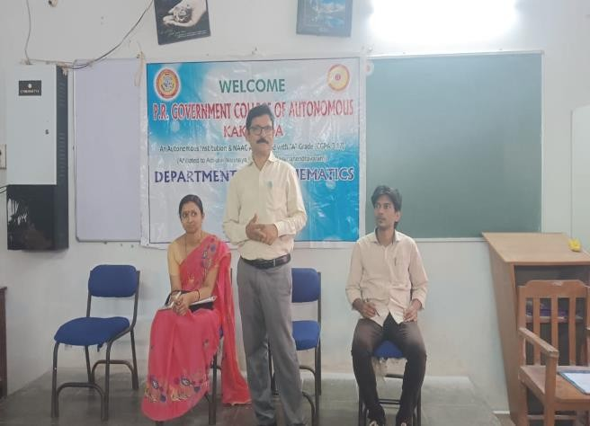
Photo Gallery

